**Exercise No: 1**

**Date: 10-10-2020**

_______________________________________________________________________

**AIM:** To write a Python program to print the calendar of a given month and year.

**PROGRAM:**

import calendar

y = int(input())

s = str(y)

m = int(input())

if m<1 or m>12:

print("Invalid Input")

elif len(s)!=4:

print("Invalid Input")

else:

print(calendar.month(y,m))

**LINK:**

http://103.53.53.18/mod/vpl/forms/edit.php?id=229&userid=1802#

**OUTPUT:**

20200

10

Invalid Input

2020

13

Invalid Input

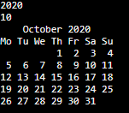

**RESULT:** Thus, theprogram to print the calendar of a given month and year is executed.